Know Your Bear Attractants
Be a Good Neighbor, Secure Bear Attractants on Your Property!
Food and Garbage
Food left outside or in open building
Soda, sweetened beverages
Beer, wine, cider, grain-based beverages
Food preparation odors
Unsecured garbage and empty garbage containers
Empty recycling cans
Cans or jars of food
Freezer – with or without food
Coolers – with or without food
BBQ grills
Food smokers
Burn barrel with unburned materials
Fire rings with unburned food
Harvested game meat
Pet and Livestock Feed
Dog, cat, rabbit or other pet food
Grain and chicken feed
Birdfeeders, seed, and suet
Bring birdfeeders down April 1st-Dec 1st
Hummingbird feeders
Fish food for fish in outdoor ponds
Molasses and animal supplement blocks
Game blocks
Blood, raw meat, or guts
Untanned animal hides
Livestock carcasses and bone yards

Garden
Compost with meat, fruit, or vegetable scraps
Compost with just grass and leaves is ok
Ripe fruit on trees and ground
Other fruits or vegetables outside
Nuts or trees on ground
Fertilizer
Other
Soap, shower gel, essential oils
Shampoo, conditioner, toothpaste
Motor oil
Antifreeze
Gasoline
Windshield washer fluid
Car cleaning products
Paint, varnish, paint thinner, lacquers,
Cleaning agents
Plastic and foam rubber in chairs and seats

Secure Your Trash with a Bear-Resistant Garbage Container!
Bears Have an Excellent Sense of Smell...
Keep all garbage containers and other attract-ants in secured garages or sheds where possible even bear-resistant ones. Bear-resistant garbage containers are the last line of defense!
Use plastic bags with ties to contain all garbage to avoid spills.
Freeze smelly garbage and discard it in the container on pickup day.
Put your garbage container out the morning of pickup, when possible.

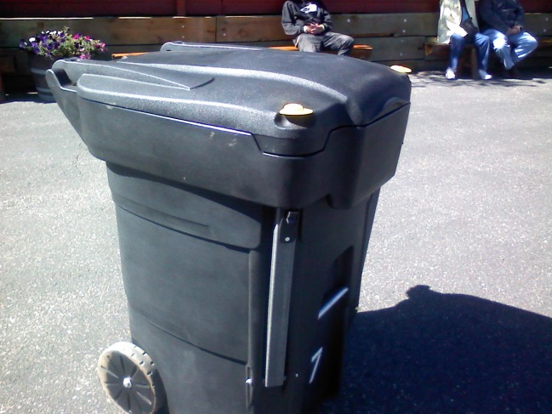
Keep Your Garbage Container Clean and Working Properly...
Clean your container with a very dilute bleach/water solution to remove smells. Wipe away any waste residue.
Prevent the latches from freezing come cooler temperatures, by spraying WD-40 on the latch mechanism.
Develop your own tricks for storing garbage and other attractants, and pass the word along to your neighbors. The best ideas come from inventive community members!
Be a good neighbor – help prevent human-bear conflicts

